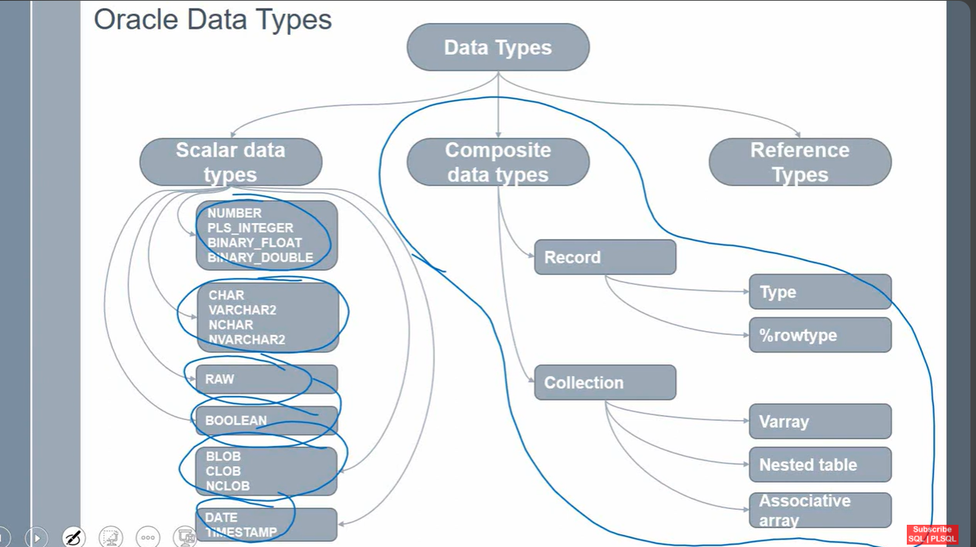

Scalar Data type :

Example

DECLARE

V_STD_NAME VARCHAR2(100);

V_STD_ADDRESS VARCHAR2(500);

BEGIN

SELECT STD_NAME , STD_ADDRESS

INTO V_STD_NAME , V_STD_ADDRESS

FROM STUDENT

WHERE STUDENT_ID = 4;

DBMS_OUTPUT.PUT_LINE('Name : '||V_STD_NAME);

DBMS_OUTPUT.PUT_LINE('Address : '||V_STD_ADDRESS);

END;

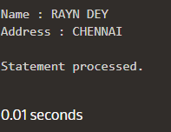

Composite Data type

Record Type

Example

DECLARE

V_REC_TYPE STUDENT%ROWTYPE;

BEGIN

SELECT *

INTO V_REC_TYPE

FROM STUDENT

WHERE STUDENT_ID = 4;

DBMS_OUTPUT.PUT_LINE('Name : '||V_REC_TYPE.STD_NAME);

DBMS_OUTPUT.PUT_LINE('Address : '||V_REC_TYPE.STD_ADDRESS);

END;

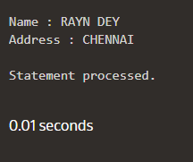

DECLARE

TYPE V_Array_Type IS VARRAY(6) OF VARCHAR2(20);

v_day V_Array_Type := V_Array_Type(NULL,NULL,NULL,NULL,NULL,NULL);

BEGIN

v_day(1) := 'MONDAY';

v_day(2) := 'TUESDAY';

v_day(3) := 'THURSDAY';

v_day(4) := 'WEDNESDAY';

v_day(5) := 'FRIDAY';

v_day(6) := 'SATURDAY';

FOR I IN 1..6

LOOP

DBMS_OUTPUT.PUT_LINE(v_day(I));

END LOOP;

END;

Collection is an ordered group of logically related elements

-List of employee names

-Address of employee

-------------Below code can hold 1 row of the cursor

DECLARE

CURSOR C1 IS SELECT ENAME ,JOB , SAL FROM EMP;

V_REC_TYPE C1%ROWTYPE;

BEGIN

OPEN C1;

FETCH C1 INTO V_REC_TYPE;

CLOSE C1;

DBMS_OUTPUT.PUT_LINE('Name : '||V_REC_TYPE.ENAME);

DBMS_OUTPUT.PUT_LINE('Job : '||V_REC_TYPE.JOB);

DBMS_OUTPUT.PUT_LINE('Sal : '||V_REC_TYPE.SAL);

END;

RECORD TYPE DEFINED IN PL/SQL BLOCK IS LOCAL TYPE

DEFINED IN PACKAGE SPECIFICATION IS PUBLIC ITEM

Assigning the value to the record-------------------

DECLARE

TYPE EMP_REC_TYPE IS RECORD(ENAME VARCHAR2(100),

SAL NUMBER);

V_EMP_REC EMP_REC_TYPE;

BEGIN

V_EMP_REC.ENAME := 'Swagata';

V_EMP_REC.SAL := 20;

DBMS_OUTPUT.PUT_LINE('V_EMP_REC.ENAME : '||V_EMP_REC.ENAME);

DBMS_OUTPUT.PUT_LINE('V_EMP_REC.SAL : '||V_EMP_REC.SAL);

END;

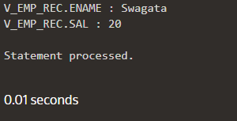

Assigning value using constructor-------------------------

DECLARE

TYPE EMP_REC_TYPE IS RECORD(ENAME VARCHAR2(100),

SAL NUMBER);

V_EMP_REC EMP_REC_TYPE := EMP_REC_TYPE('Swagata' , 40);

BEGIN

DBMS_OUTPUT.PUT_LINE('V_EMP_REC.ENAME : '||V_EMP_REC.ENAME);

DBMS_OUTPUT.PUT_LINE('V_EMP_REC.SAL : '||V_EMP_REC.SAL);

END;

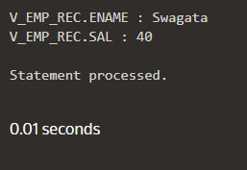

Record type using database table----------------

DECLARE

TYPE EMP_REC_TYPE IS RECORD (ENAME VARCHAR2(100),

SAL NUMBER);

V_EMP_REC EMP_REC_TYPE;

BEGIN

SELECT ENAME , SAL

INTO V_EMP_REC

FROM EMP

WHERE EMPNO = 117;

DBMS_OUTPUT.PUT_LINE('V_EMP_REC.ENAME : '||V_EMP_REC.ENAME);

DBMS_OUTPUT.PUT_LINE('V_EMP_REC.SAL : '||V_EMP_REC.SAL);

END;

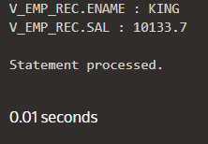

TYPE ---is use to define a record---custom record definition

%rowtype --- is to define datatype

Varray---------

DECLARE

TYPE V_ARRAY_TYPE IS VARRAY(6) OF VARCHAR2(30);

v_day V_ARRAY_TYPE := V_ARRAY_TYPE(NULL,NULL,NULL,NULL,NULL,NULL);

BEGIN

v_day(1) := 'Monday';

v_day(2) := 'Tuesday';

v_day(3) := 'Wednesday';

v_day(4) := 'Thursday';

v_day(5) := 'Friday';

v_day(6) := 'Saturday';

dbms_output.put_line(v_day(1));

dbms_output.put_line(v_day(2));

dbms_output.put_line(v_day(3));

dbms_output.put_line(v_day(4));

dbms_output.put_line(v_day(5));

END;

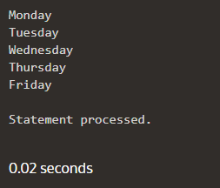

Using Extend keyword-------------

DECLARE

TYPE V_ARRAY_TYPE IS VARRAY(6) OF VARCHAR2(30);

v_day V_ARRAY_TYPE := V_ARRAY_TYPE();

BEGIN

v_day.extend(2);

v_day(1) := 'Monday';

v_day(2) := 'Tuesday';

dbms_output.put_line(v_day(1));

dbms_output.put_line(v_day(2));

END;

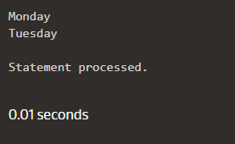

----------END --------------------

**D - 28/5/24**

**Topic : Types of PL/SQL Collections**

**-----------------------------------------Associative Arrays--------------------------------------------------**

***Example 1:==============================***

DECLARE

TYPE ASCT_DAY_TYPE IS TABLE OF VARCHAR2(15) INDEX BY VARCHAR2(15 BYTE);

LV_DAY ASCT_DAY_TYPE;

BEGIN

LV_DAY(1):= 'Tuesday';

dbms_output.put_line(LV_DAY(1));

END;

***Example 2:================================***

DECLARE

TYPE ASCT_DAY_TYPE IS TABLE OF NUMBER INDEX BY VARCHAR2(15 BYTE);

LV_DAY ASCT_DAY_TYPE;

BEGIN

LV_DAY(1):= 52;

dbms_output.put_line(LV_DAY(1));

END;

***Example 3:================================***

DECLARE

TYPE ASCT_EMP_TYPE IS TABLE OF VARCHAR2(15) INDEX BY BINARY_INTEGER;

LV_EMP ASCT_EMP_TYPE;

I NUMBER := 0;

CURSOR EMP_CUR IS SELECT ENAME FROM EMP WHERE ROWNUM<=12;

BEGIN

FOR J IN EMP_CUR LOOP

I := I+1;

LV_EMP(I) := J.ENAME ;

END LOOP;

FOR K IN 1..12 LOOP

DBMS_OUTPUT.PUT_LINE(LV_EMP(K));

END LOOP;

END;

**D - 29/5/24**

***Example 5:=================================***

-------Using FIRST

DECLARE

TYPE ASCT_TEST_TYPE IS TABLE OF NUMBER INDEX BY VARCHAR2(20);

TEST_LIST ASCT_TEST_TYPE;

TEST_NAME VARCHAR2(20);

BEGIN

TEST_LIST('A') := 100;

TEST_LIST('B') := 200;

TEST_LIST('C') := 300;

TEST_LIST('D') := 400;

TEST_LIST('E') := 500;

TEST_NAME := TEST_LIST.FIRST;

WHILE TEST_NAME IS NOT null LOOP

dbms_output.put_line

('Salary of ' || TEST_NAME || ' is ' || TO_CHAR(TEST_LIST(TEST_NAME)));

TEST_NAME := TEST_LIST.NEXT(TEST_NAME);

END LOOP;

END;

***Example 6:==============================***

----Using LAST

DECLARE

TYPE ASCT_TEST_TYPE IS TABLE OF NUMBER INDEX BY VARCHAR2(20);

TEST_LIST ASCT_TEST_TYPE;

TEST_NAME VARCHAR2(20);

BEGIN

TEST_LIST('A') := 100;

TEST_LIST('B') := 200;

TEST_LIST('C') := 300;

TEST_LIST('D') := 400;

TEST_LIST('E') := 500;

TEST_NAME := TEST_LIST.LAST;

WHILE TEST_NAME IS NOT null LOOP

dbms_output.put_line

('Salary of ' || TEST_NAME || ' is ' || TO_CHAR(TEST_LIST(TEST_NAME)));

TEST_NAME := TEST_LIST.prior(TEST_NAME);

END LOOP;

END;

***Example 7:====================================***

DECLARE

CURSOR cname is select ename from emp;

TYPE ASCT_EMP_TYPE IS TABLE OF EMP.ENAME%TYPE INDEX BY PLS_INTEGER;

name_list ASCT_EMP_TYPE;

counter number := 0;

BEGIN

For i in cname LOOP

counter := counter +1;

name_list(counter) := i.ename;

dbms_output.put_line('emp ('||counter||') :'||name_list(counter));

end loop;

END;

**-------------------------------------------Nested Table----------------------------------------------------**

***Example 1:=================================***

DECLARE

TYPE NEST_NAME_TYPE IS TABLE OF VARCHAR2(100);

TYPE NEST_MARKS_TYPE IS TABLE OF NUMBER;

LV_NAMES NEST_NAME_TYPE;

LV_MARKS NEST_MARKS_TYPE;

TOTAL NUMBER;

BEGIN

LV_NAMES := NEST_NAME_TYPE('BLAKE','CLARK','JONES','SCOTT','FORD','SMITH');

LV_MARKS := NEST_MARKS_TYPE (55,88,77,99,66,89);

TOTAL := LV_NAMES.COUNT;

FOR I IN 1..TOTAL LOOP

DBMS_OUTPUT.PUT_LINE(LV_NAMES(I) ||' := '||LV_MARKS(I));

END LOOP;

END;

***Example 2:===================================***

---Using extend

DECLARE

CURSOR C_EMP IS SELECT ENAME FROM EMP;

TYPE NEST_NAME_TYPE IS TABLE OF EMP.ENAME%TYPE;

C_LIST NEST_NAME_TYPE: = NEST_NAME_TYPE ();

CNTER NUMBER: = 0;

BEGIN

FOR I IN C_EMP LOOP

CNTER := CNTER+1;

C_LIST.EXTEND;

C_LIST(CNTER) := I.ENAME;

DBMS_OUTPUT.PUT_LINE('TEST('||CNTER||')'|| C_LIST(CNTER));

END LOOP;

END;

***Example 3: ==================================***

----Addition of two nested table

DECLARE

TYPE NEST_NUM_TYPE IS TABLE OF NUMBER;

LV_VAR1 NEST_NUM_TYPE := NEST_NUM_TYPE(4,2,5);

LV_VAR2 NEST_NUM_TYPE := NEST_NUM_TYPE(2,6,9);

LV_RESULT NEST_NUM_TYPE;

BEGIN

LV_RESULT := NEST_NUM_TYPE();

LV_RESULT.EXTEND(LV_VAR1.COUNT);

FOR i IN 1..LV_VAR1.LAST LOOP

LV_RESULT(i) := LV_VAR1(i) + LV_VAR2(i);

DBMS_OUTPUT.PUT_LINE('Result of '||i || ' is ' ||LV_RESULT(i));

END LOOP;

END;

***Example 4:==========================================***

DECLARE

CURSOR C_EMP IS SELECT ENAME,SAL FROM EMP;

TYPE NEST_NAME_TYPE IS TABLE OF EMP.ENAME%TYPE;

TYPE NEST_SAL_TYPE IS TABLE OF EMP.SAL%TYPE;

C_LIST NEST_NAME_TYPE := NEST_NAME_TYPE();

C_SAL_LIST NEST_SAL_TYPE := NEST_SAL_TYPE();

CNTER NUMBER := 0;

BEGIN

FOR I IN C_EMP LOOP

CNTER := CNTER+1;

C_LIST.EXTEND;

C_SAL_LIST.EXTEND;

C_LIST(CNTER) := I.ENAME;

C_SAL_LIST(CNTER) := I.SAL;

DBMS_OUTPUT.PUT_LINE('NAME ('||CNTER||') := '|| C_LIST(CNTER)||', SALARY := '|| NVL(C_SAL_LIST(CNTER),0));

END LOOP;

END

**-------------------------------------------VArray----------------------------------------------------**

***Example 1:==============================***

DECLARE

TYPE V_TEST_TYPE IS VARRAY(4) OF VARCHAR2(100);

V_TEST V_TEST_TYPE := V_TEST_TYPE();

BEGIN

V_TEST.EXTEND(4);

V_TEST(1) := 'Monday';

V_TEST(2) := 'Tuesday';

V_TEST(3) := 'Wednesday';

V_TEST(4) := 'Thursday';

FOR i IN 1..4 LOOP

DBMS_OUTPUT.PUT_LINE(V_TEST(i));

END LOOP;

END;

***Example 2:======================================***

DECLARE

TYPE V_TEST_TYPE IS VARRAY(4) OF VARCHAR2(100);

V_TEST V_TEST_TYPE := V_TEST_TYPE(NULL,NULL,NULL,NULL);

BEGIN

-- V_TEST.EXTEND(4);

V_TEST(1) := 'Monday';

V_TEST(2) := 'Tuesday';

V_TEST(3) := 'Wednesday';

V_TEST(4) := 'Thursday';

FOR i IN 1..4 LOOP

DBMS_OUTPUT.PUT_LINE('Day '||i||' : '||V_TEST(i));

END LOOP;

END;

***Example 3:========================================***

DECLARE

TYPE V_EMP_TYPE IS VARRAY(10) OF VARCHAR2(10);

V_ENAME V_EMP_TYPE := V_EMP_TYPE();

counter NUMBER := 0;

BEGIN

FOR i IN (SELECT ENAME FROM EMP WHERE ROWNUM<10)

LOOP

counter := counter + 1;

V_ENAME.EXTEND();

V_ENAME(counter) := I.ENAME;

DBMS_OUTPUT.PUT_LINE(counter||V_ENAME(counter));

END LOOP;

END;

**========================================================**

**\*\*\*\*\*\*\*\*Record type with nested table\*\*\*\*\*\*\*\*\*\***

DECLARE

TYPE REC_TYPE IS RECORD (ENAME VARCHAR2(200), JOB VARCHAR2(200));

TYPE NEST_TEST_TYPE IS TABLE OF REC_TYPE;

LV_TEST NEST_TEST_TYPE;

counter NUMBER;

BEGIN

LV_TEST := NEST_TEST_TYPE(REC_TYPE('A' , 'JOB A'),

REC_TYPE('B' , 'JOB B'),

REC_TYPE('C' , 'JOB C'));

counter := LV_TEST.COUNT;

FOR i IN 1..counter

LOOP

DBMS_OUTPUT.PUT_LINE('ENAME : '||LV_TEST(i).ENAME||' , JOB : '||LV_TEST(i).JOB);

END LOOP;

END;

Swagata